**Unit-Tests are being created for each piece of code that is testable in this way –**

Unit tests for each piece of code are developed specifically for it. We'll need a range of methods to complete the testing. Below is a list of the many stages of testing.

The process of writing a test goes through many phases:

Level 1: Initial instances will be created using pre-existing requirements and user guides, and they will be made available to users.

Level 2: This is the hardest level to reach. When creating scenarios at this level, care is given to the application's real functionality and system flow.

Level 3: Step three involves creating a test plan for a variety of possible circumstances. There are just a few cases in the test method, and the maximum number is 10.

Level 4: The project is now being automated to the fourth level. QA may therefore concentrate on testing the most recent feature rather than on regression testing since human involvement will be minimized.

**A library project is present and classes are being created**

The email management system has been divided into multiple groups. Compose mail and calendar is also available. Below you'll find some screenshots.

**Compose Email:**

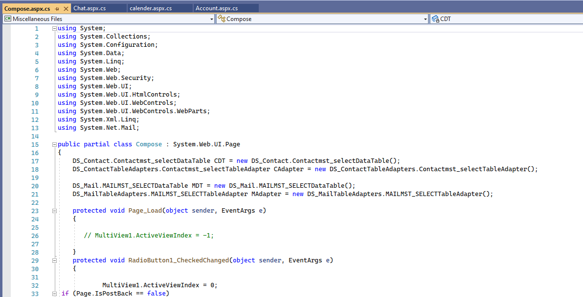

**Chat:**

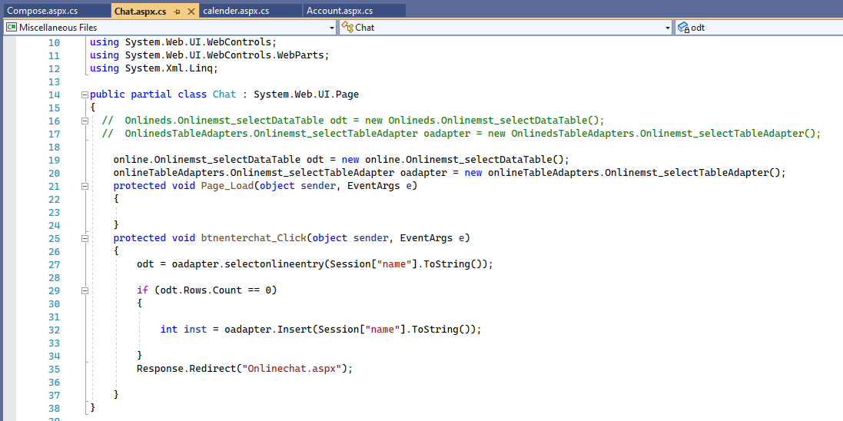

**Calendar**

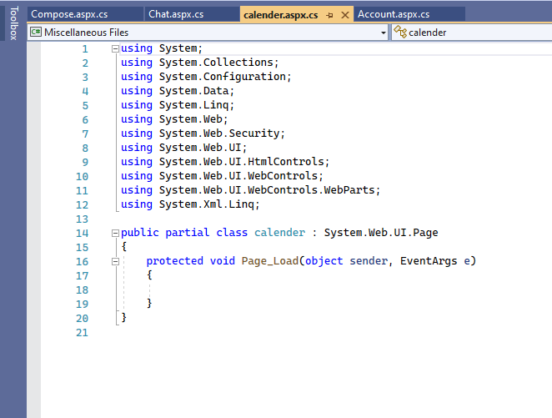

**Accounts:**

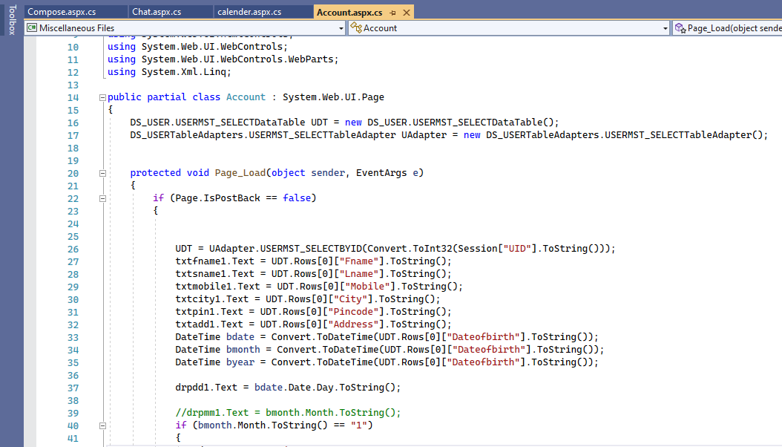

**User Interface**

**Ui is being created and functional**

**Account Create**

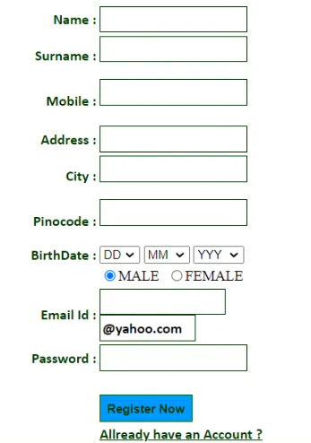

**Password Set:**

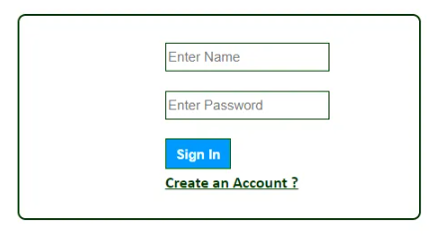

**Compose Email:**

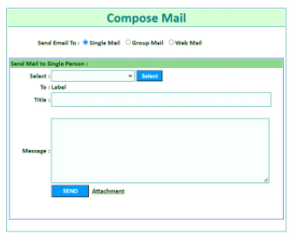

Working on other GUI as well.

**Using all controllers to send and receive requests from and to the app is recommended.**

**Work on Data Attributes must begin**

**Server validations should be implemented.**

**LINQ should be used to write queries.**

**Procedure**

SQL Server Management Studio: Right-click Database Mail and choose Send Test E-Mail from the Object Explorer's menu bar to send a test email. If the user does not already have a database mail profile, the Database Mail Configuration Wizard is initiated.

In the Send Test Email from instance name> dialogue box, choose the database mail profile you want to use from the drop-down menu.

It is important to put the recipient's email address in the To field.

Type the first line of the test e-subject message in the Subject area. Alter the default subject line for debugging reasons.

This is where you'll input the body of your email. Modify the email's default subject line to aid with troubleshooting.

You may send a test email to the Database Mail queue by selecting Submit Test E-Mail from the Mail menu.

After sending a database mail test email, the Database Mail Test E-Mail dialogue box appears. Please monitor the amount of emails sent from your inbox. This message's id may be found here. If you want to proceed, all you have to do is pick "Yes."

The query editor will appear after clicking New Query from the Toolbar. There are a few of ways to find out what's happening with your test email message on the server:

 In this column, we can see whether the test email was indeed sent or not.

The error message may be seen by using the command:

Writing integration tests for your user interface is an absolute must.

